**Advanced Programming**

**Lab 4**

**Syed Zain Ul Abideen Gillani, 124021, BSCS 5C**

**TASK 1**

**Part(i)**



**Part(ii)**



**Part(iii)**

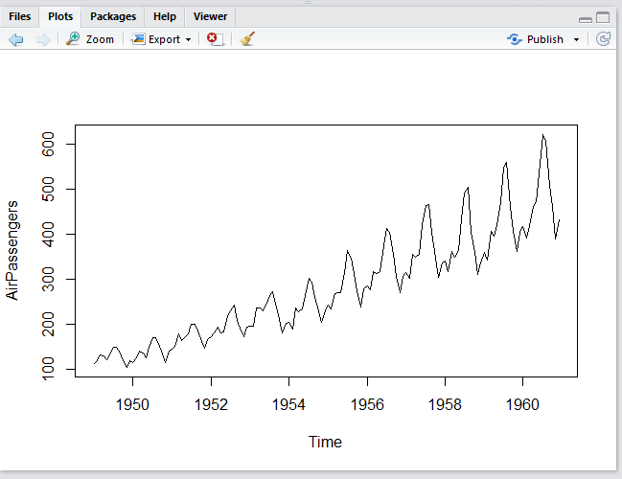

**TASK 2**

**Part(i)**



**Part (ii)**



**TASK 3**

